**Advanced Databases**

**MongoDB CA**

**Student Number:** C19513256

**Student Name:** Barnet Obeka

**Programme Code:** TU856

1. Setting up the cluster and replication

<<describe your cluster, now many nodes etc.>









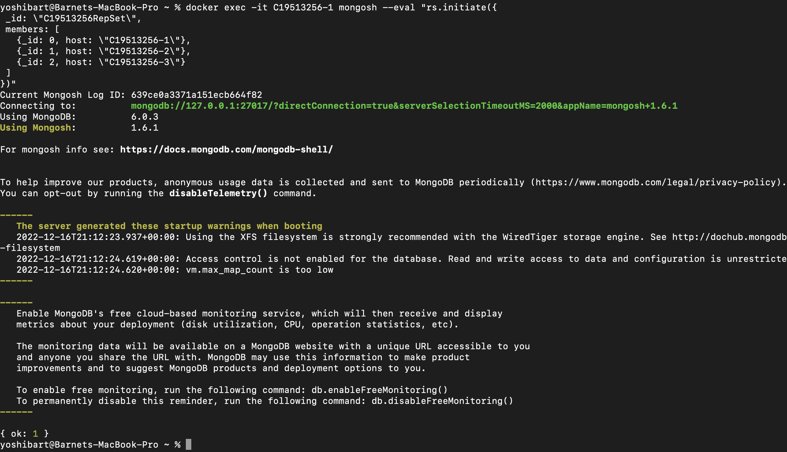

<<use rs.status to verify that the cluster and replication is working, include a screenshot, comment on the information provided>>

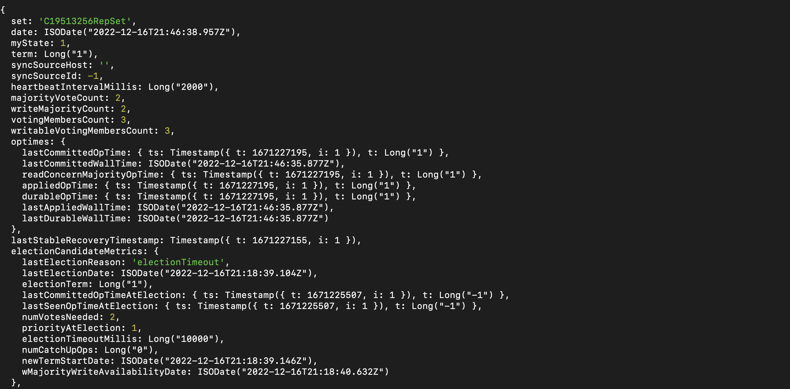

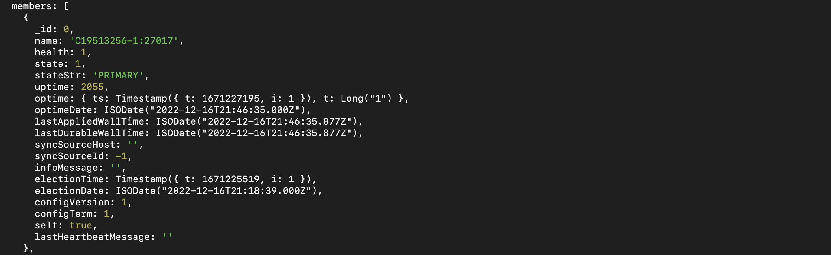

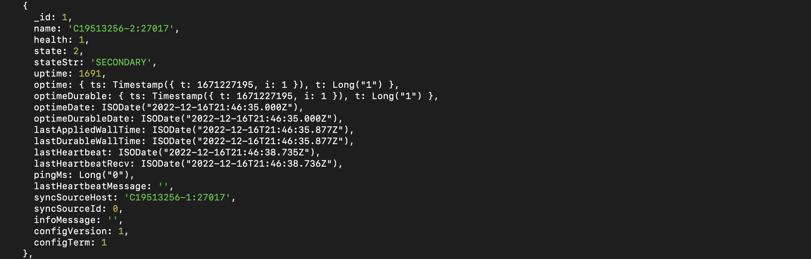

1. Porting the data to Mongo

<<verify that the data exists>>

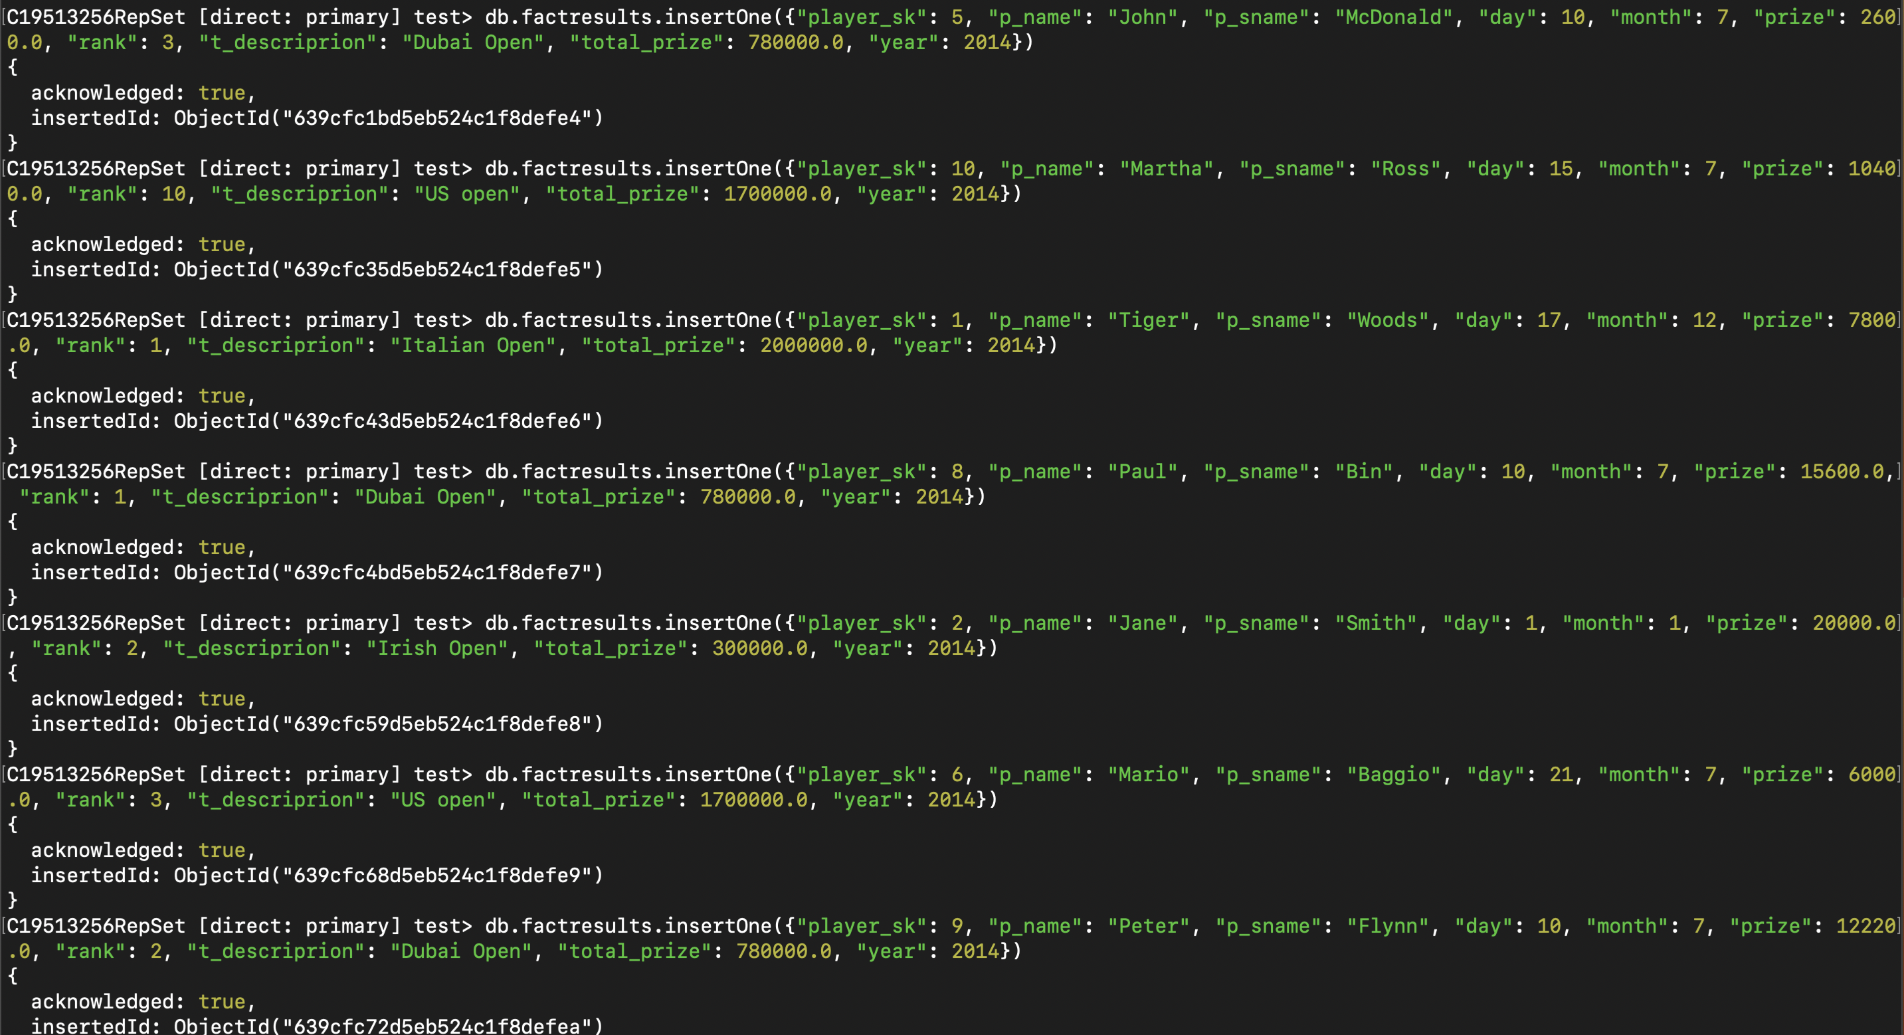

<<use db.collection.find >>

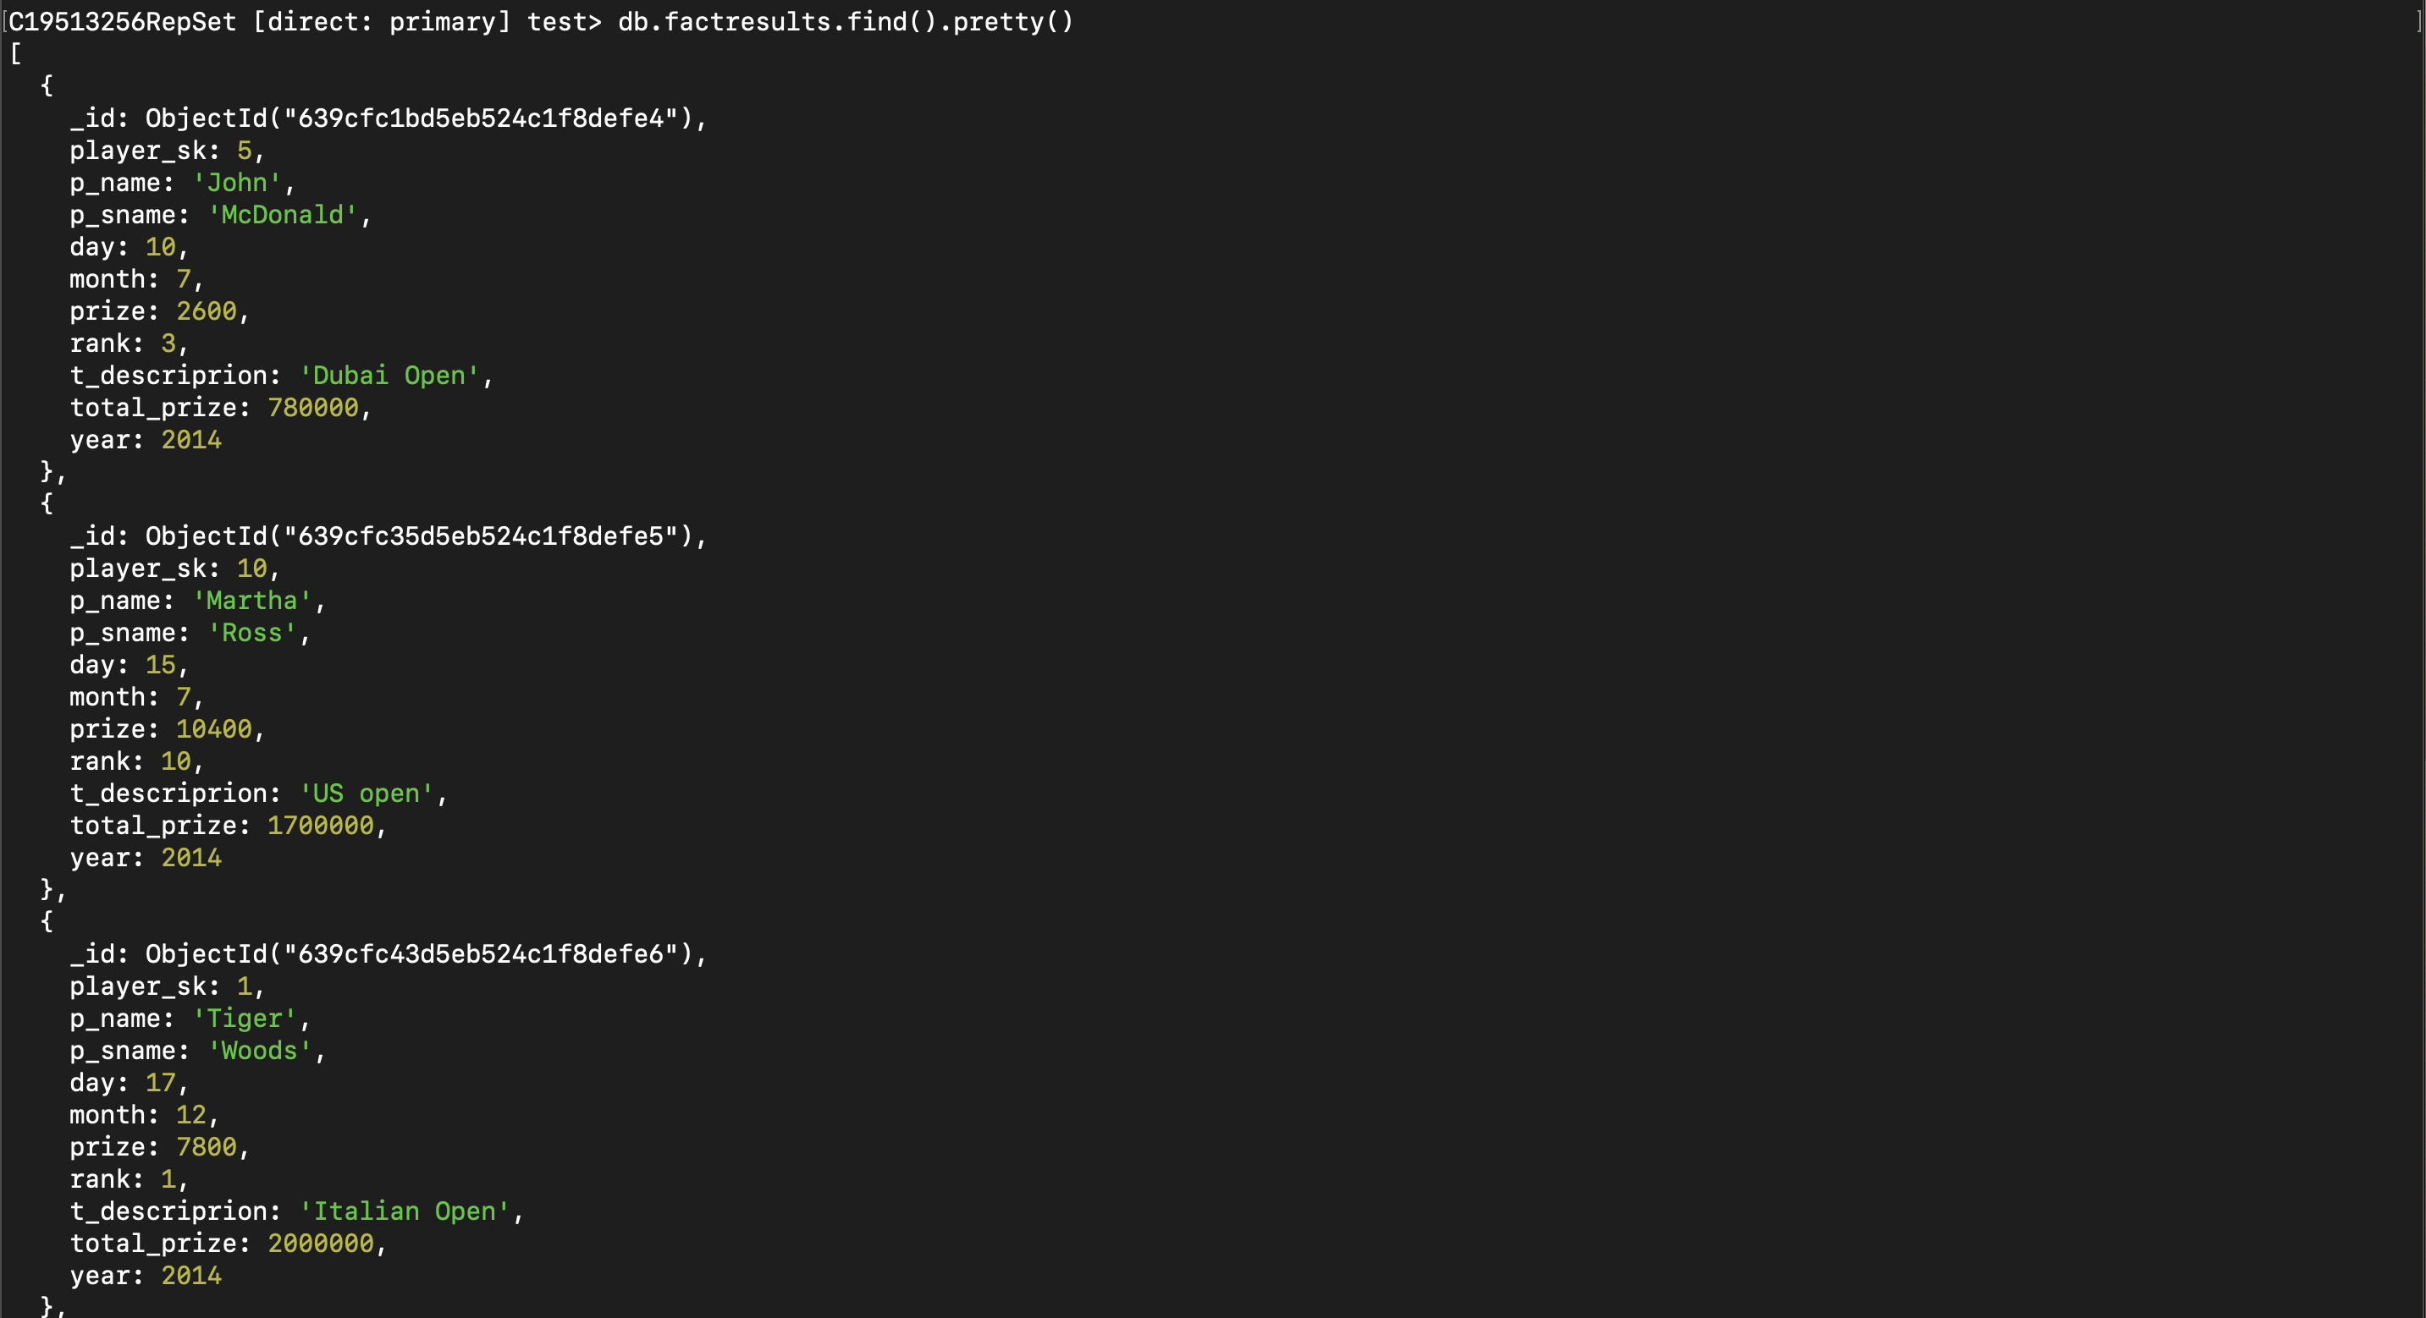

1. Working with the Golf collection in MongoDB:
   1. Basic query on golf data involving a text field.

<<use explain, capture the output and include it here, comment on what is happening>>

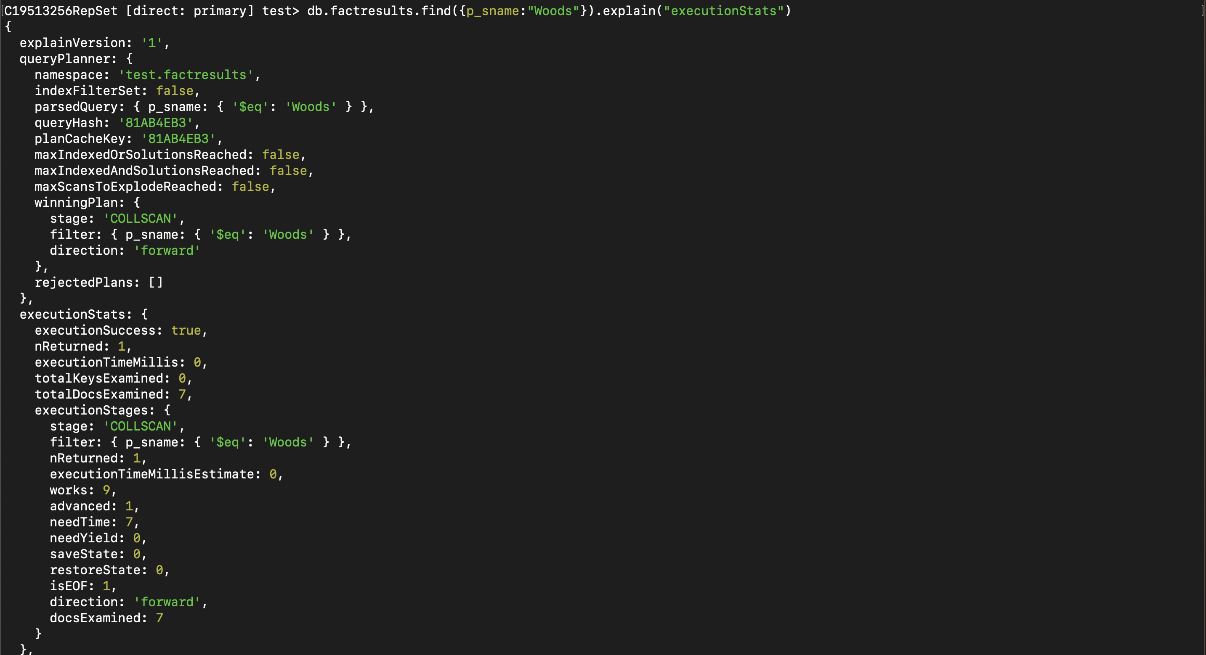

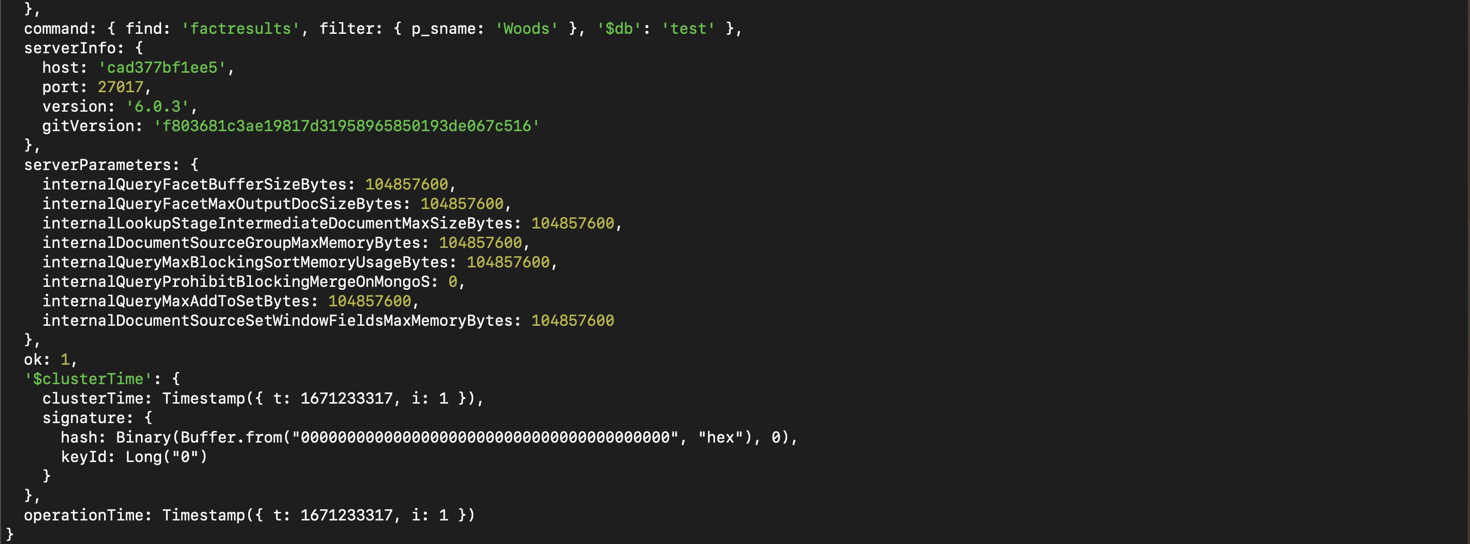

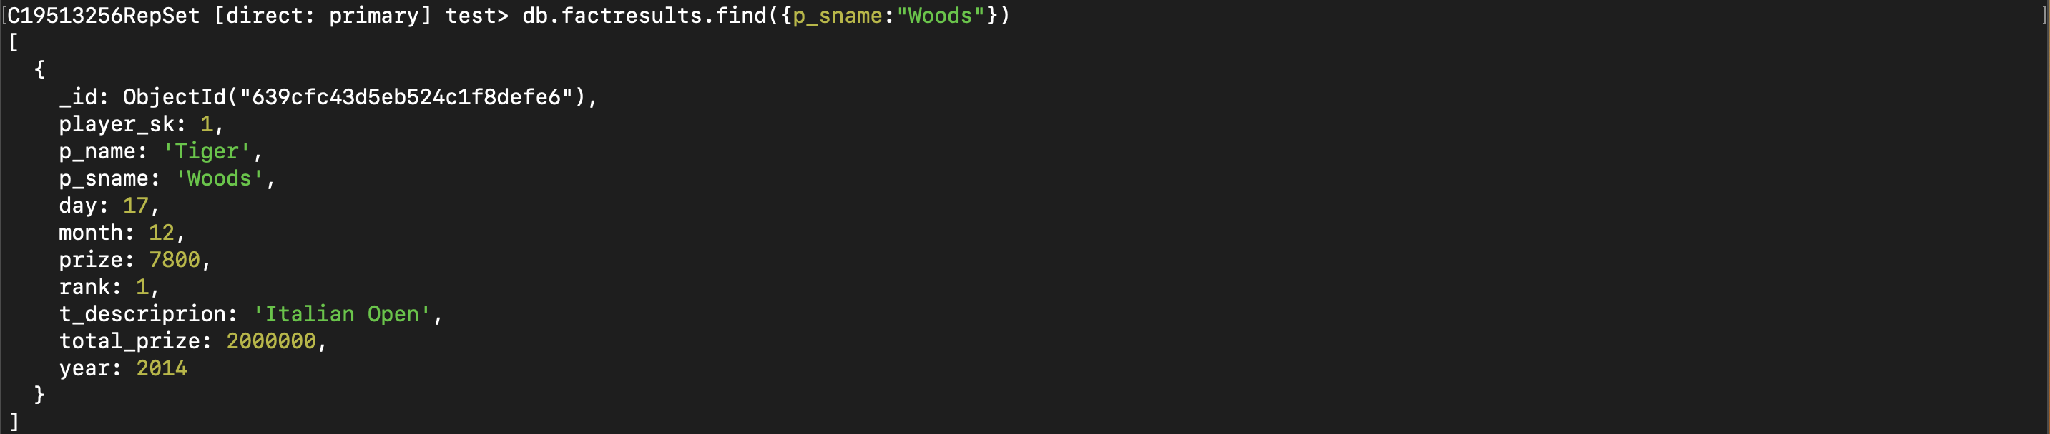

* 1. Adding a secondary index to golf data on a text field.

<<use explain, capture the output and include it here, comment on what is happening>>



Verification

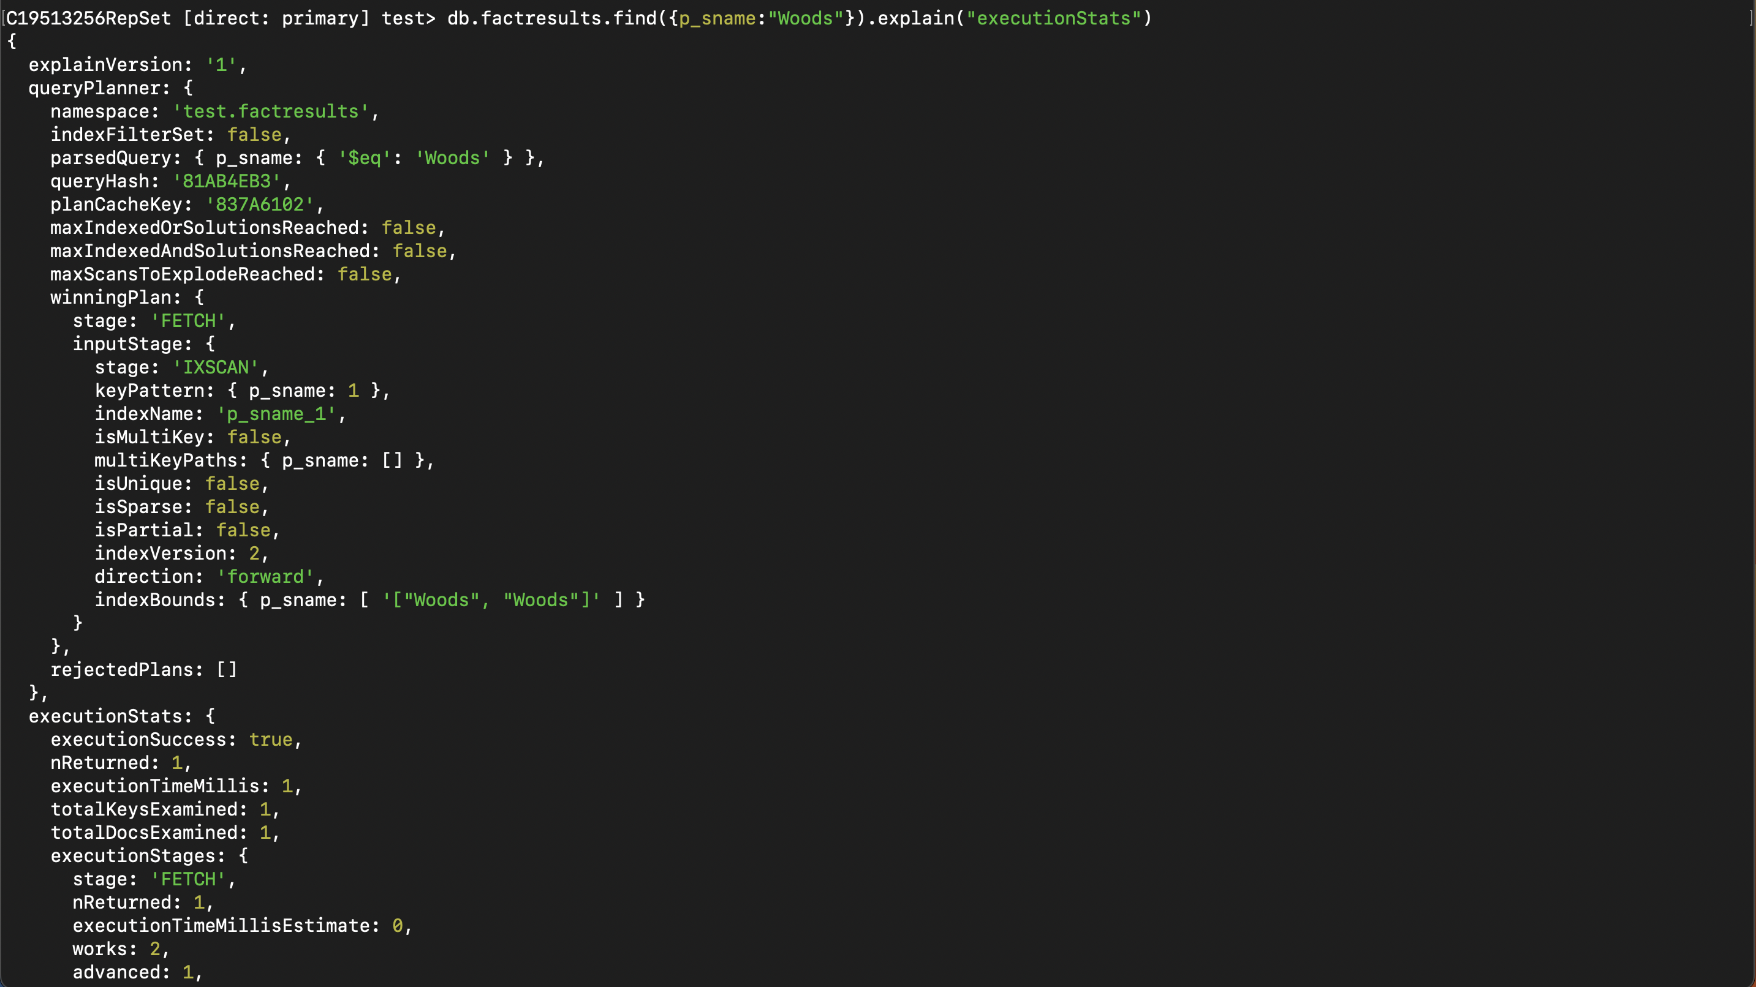

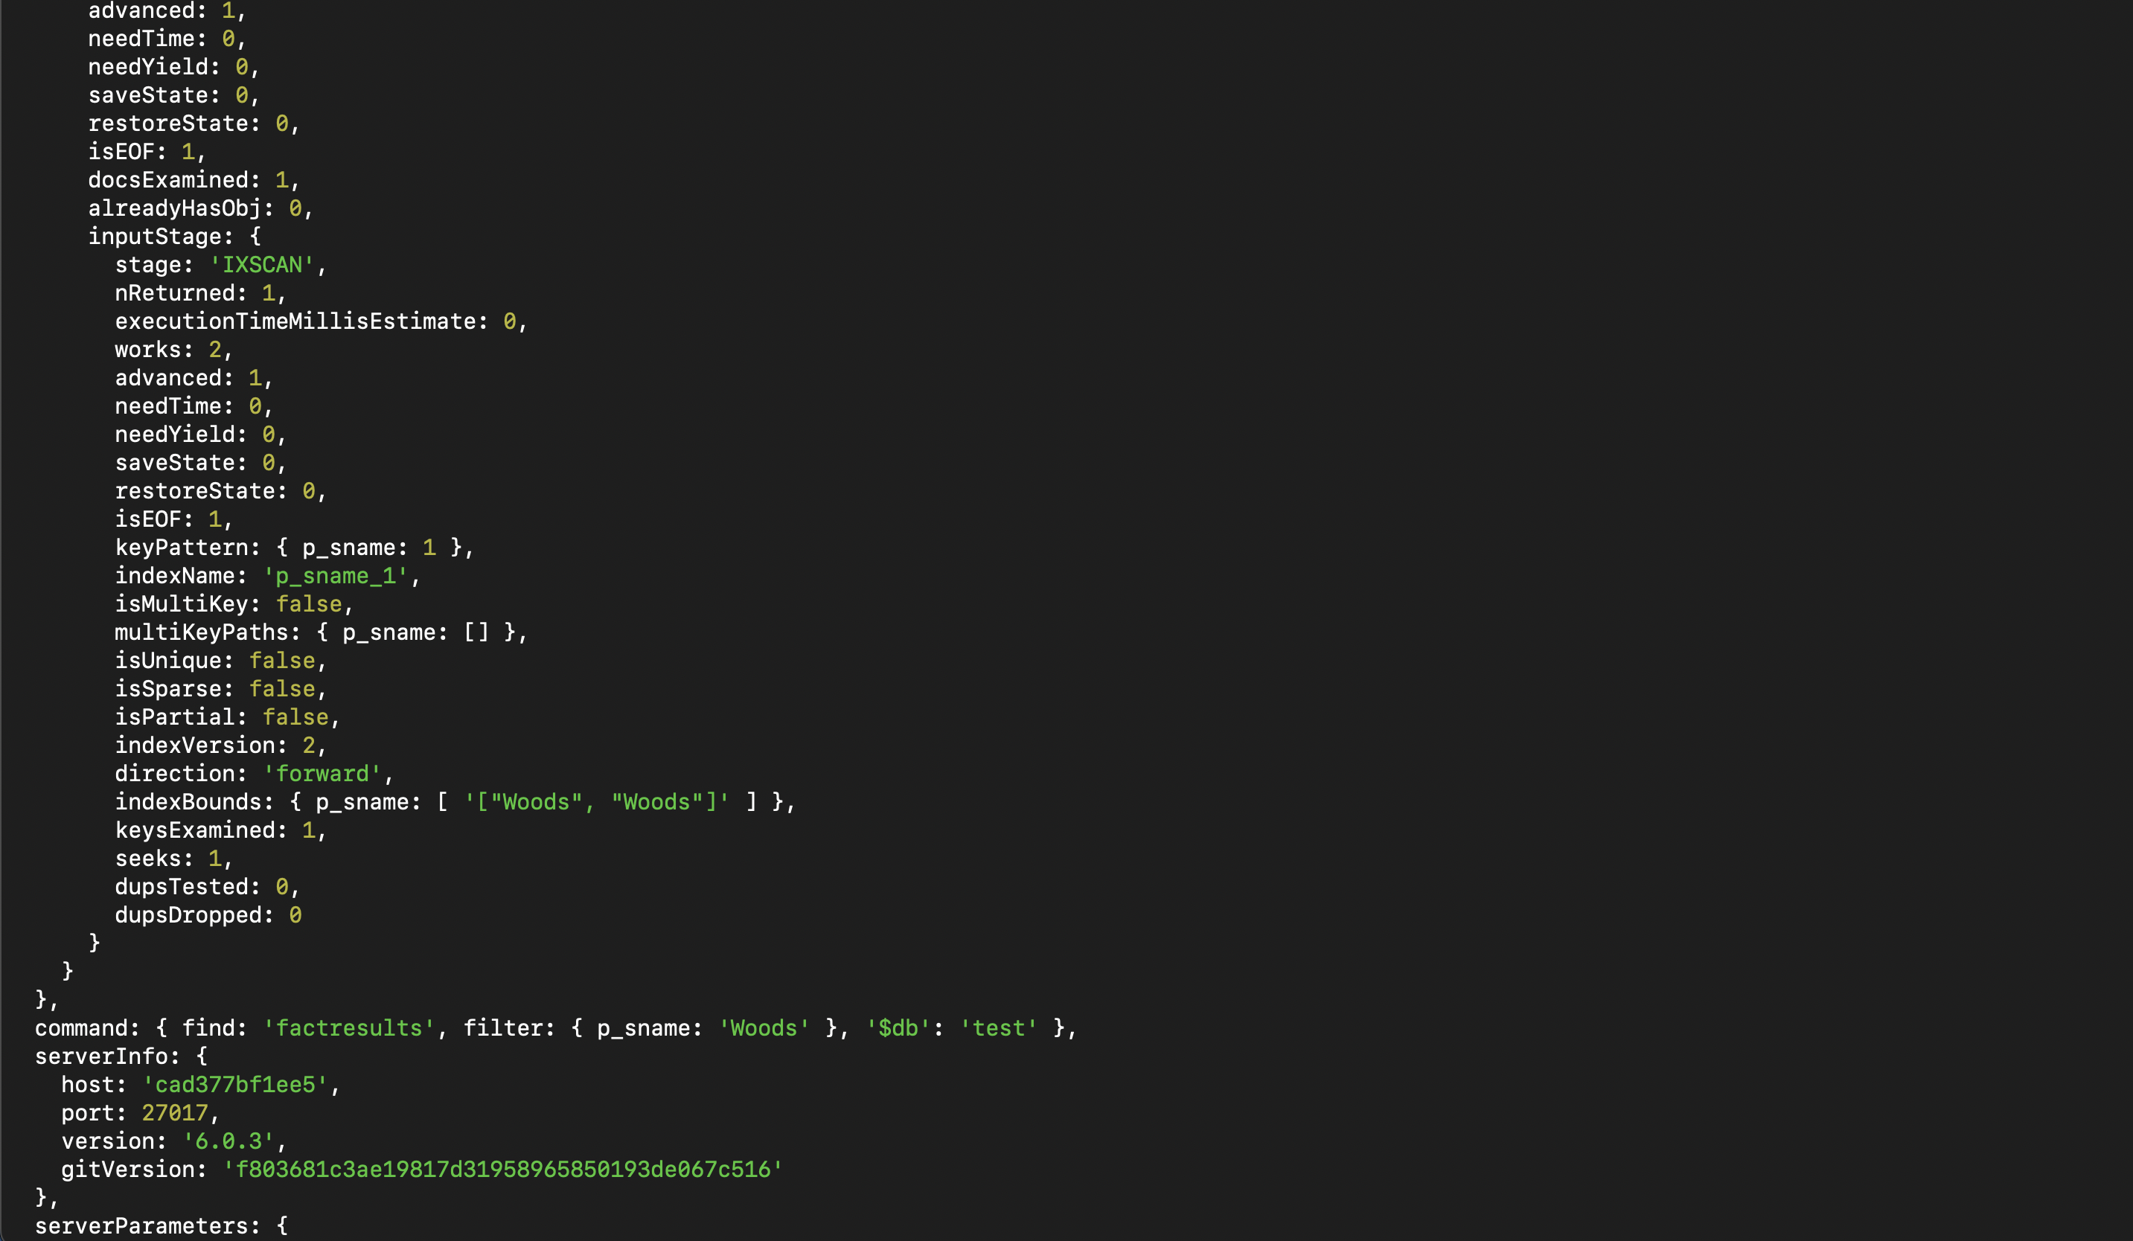

1. Working with aggregation in MongoDB:
   1. Create an aggregation pipeline

<<use explain, capture the output and include it here, comment on what is happening>>

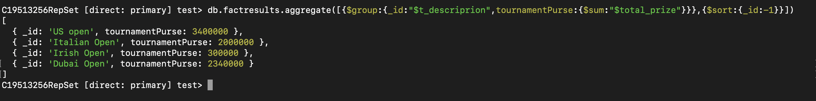

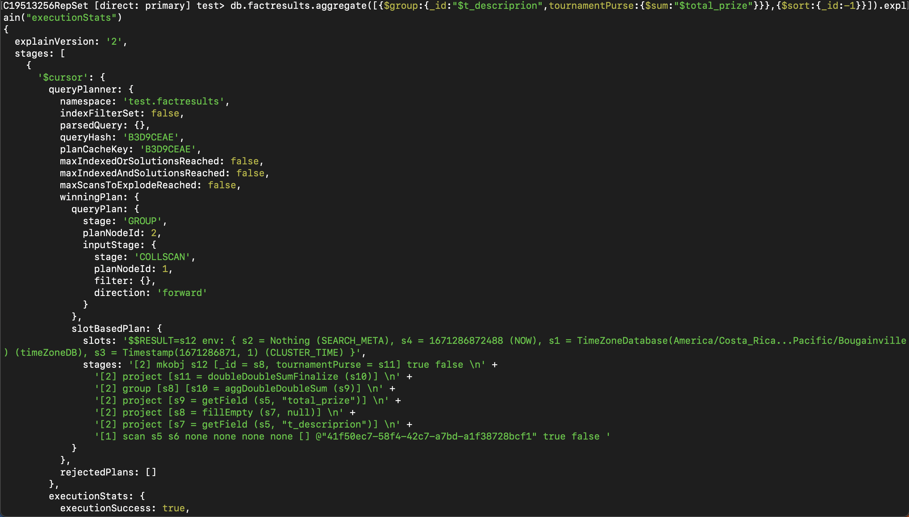

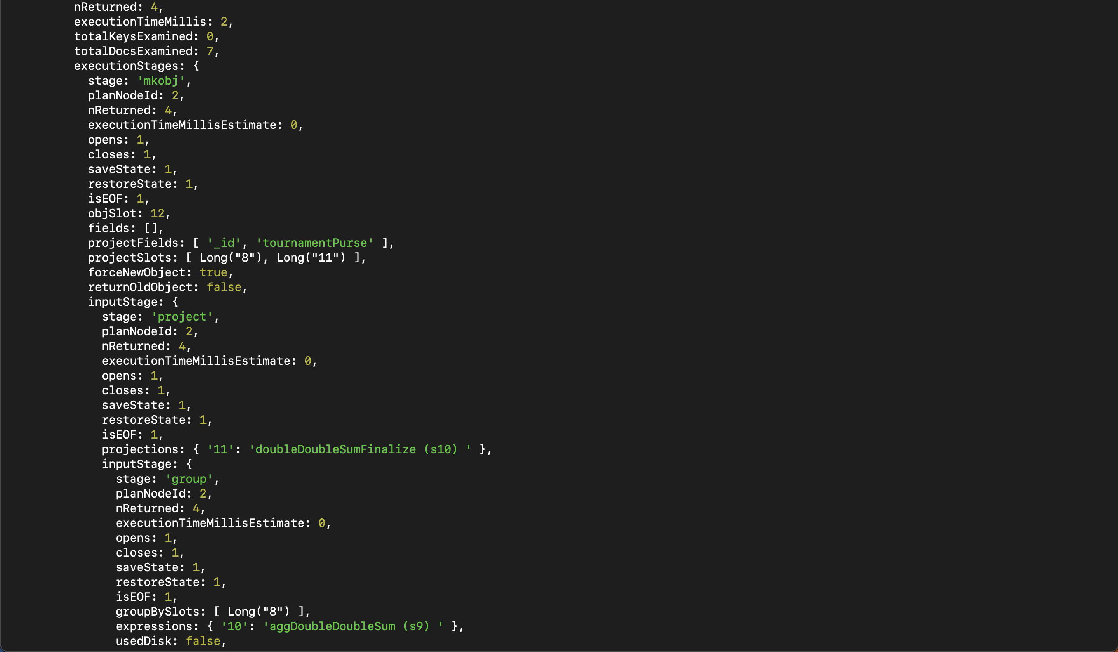

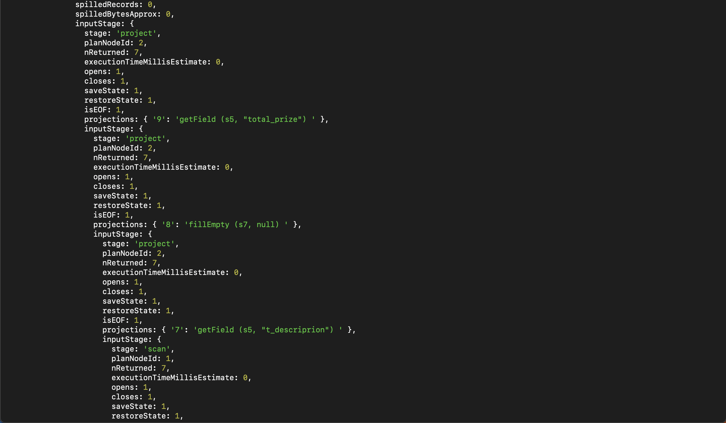

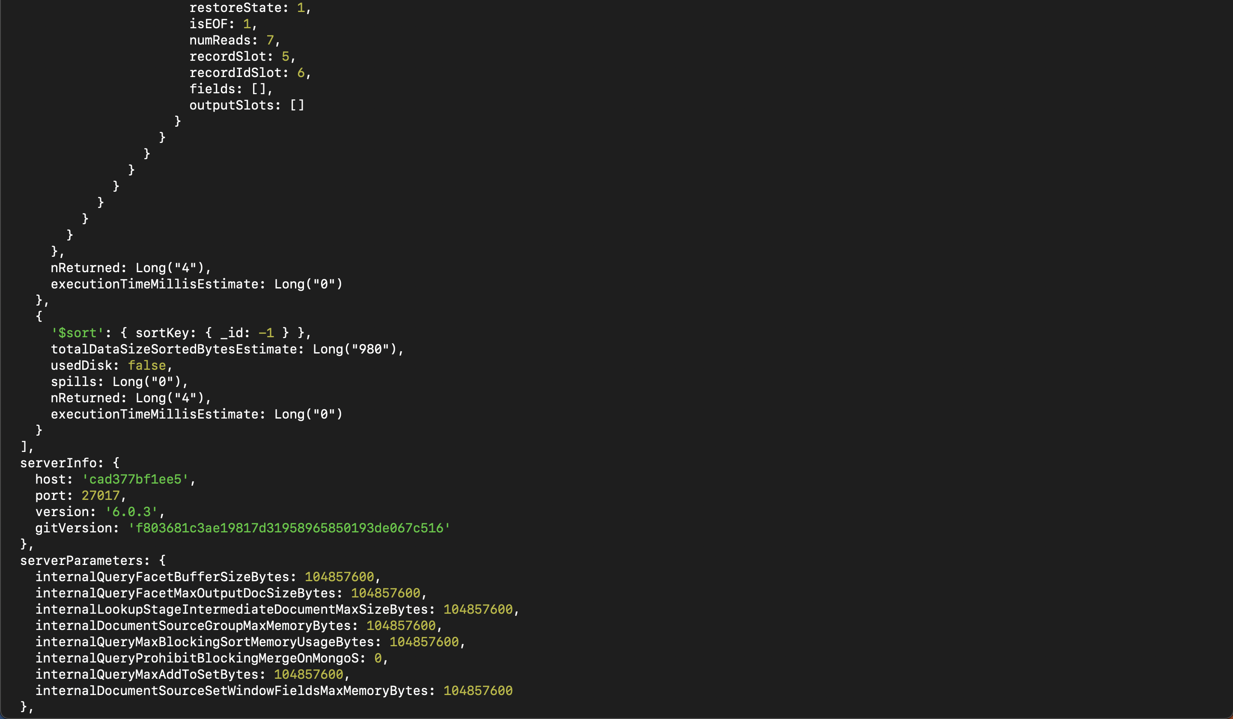

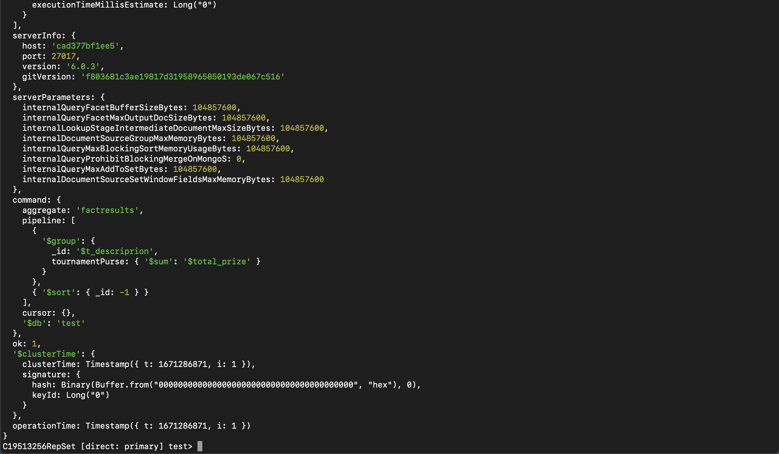

* 1. Add relevant indexes and reorder your stages.

<<use explain, capture the output and include it here, comment on what is happening>>



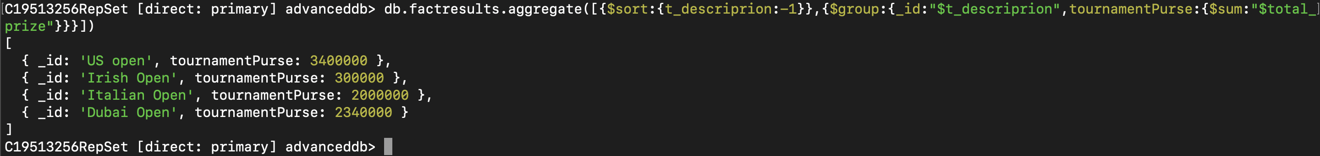

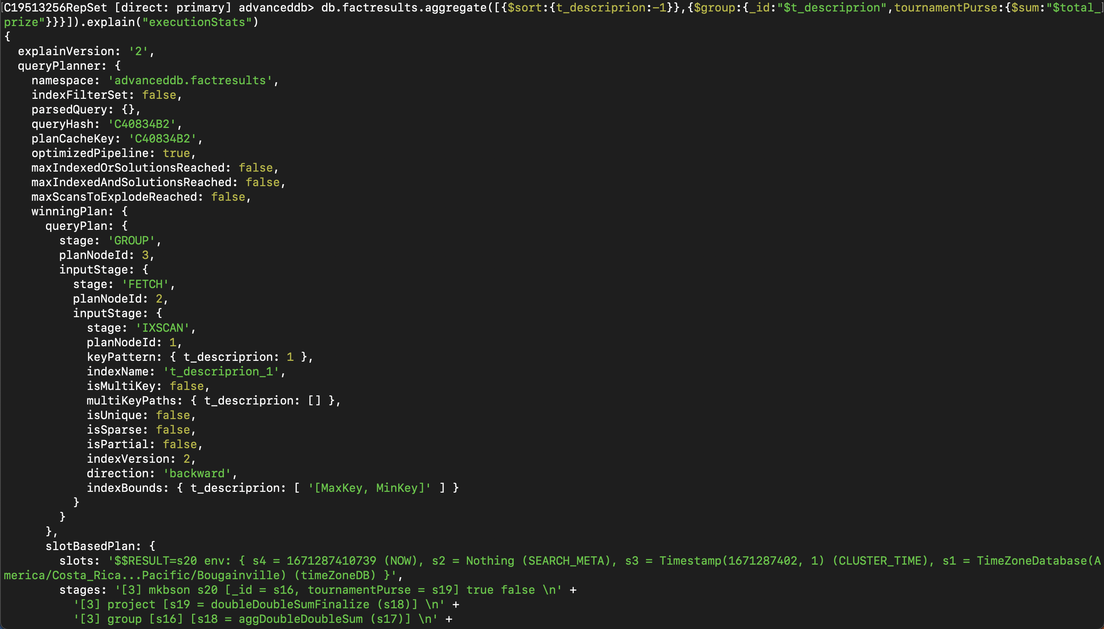

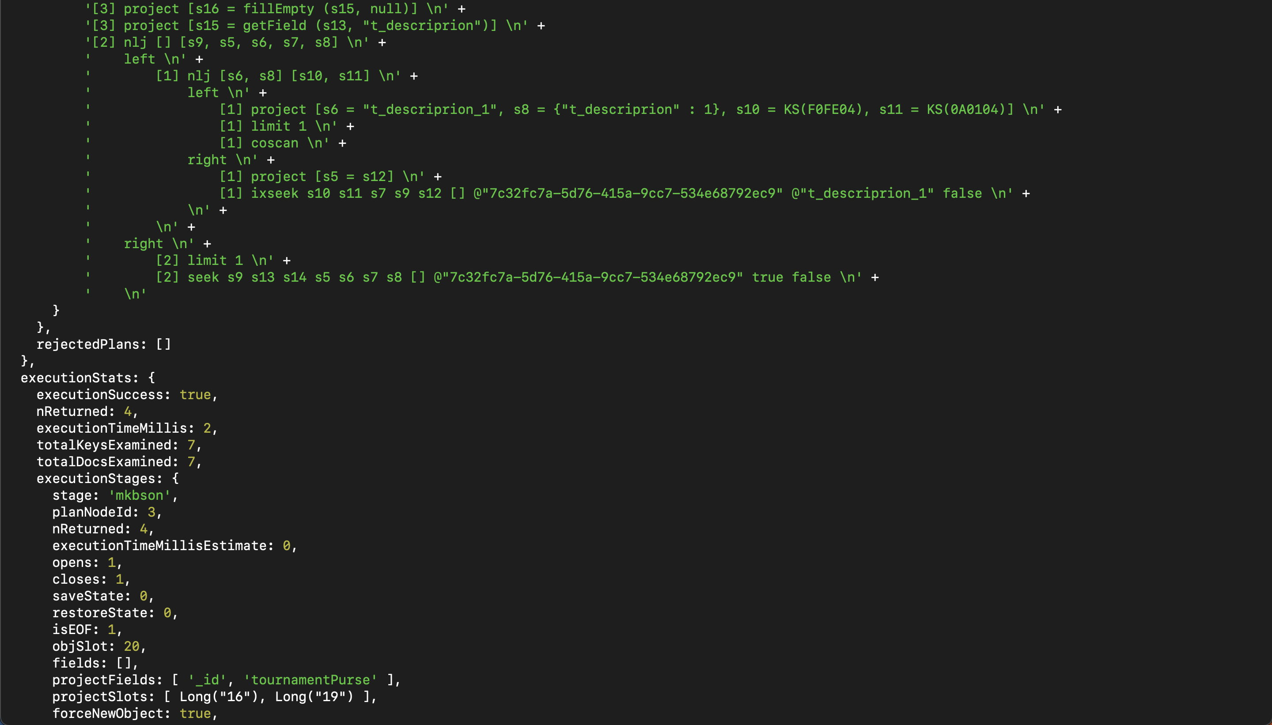

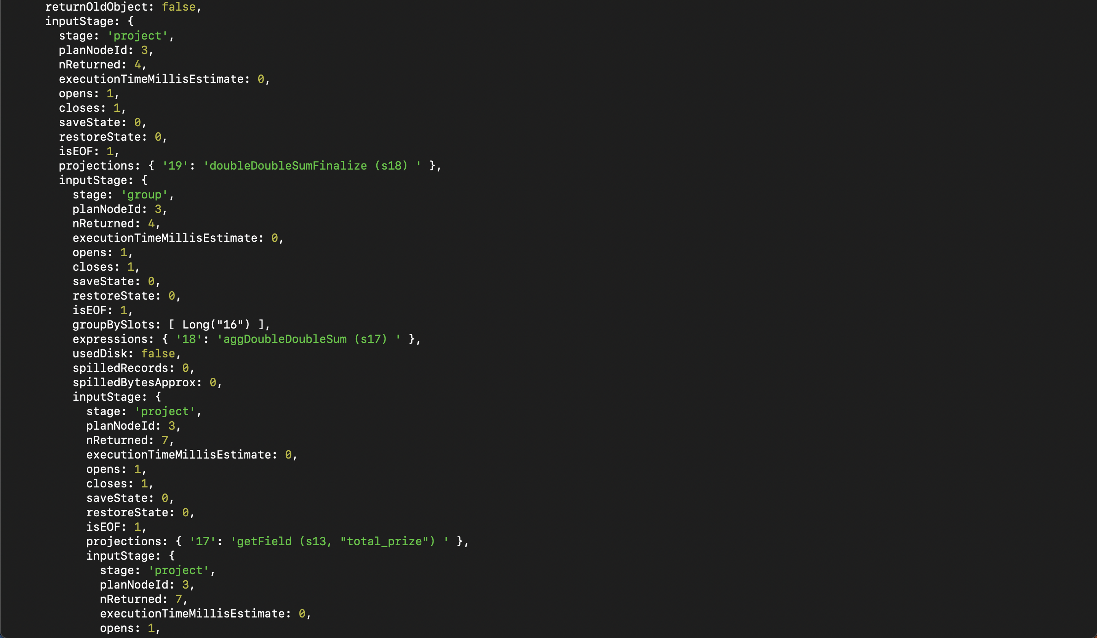

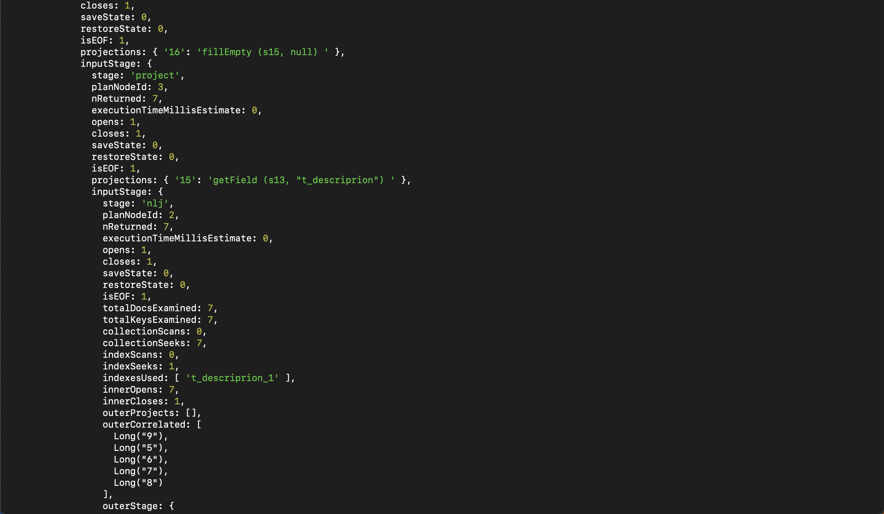

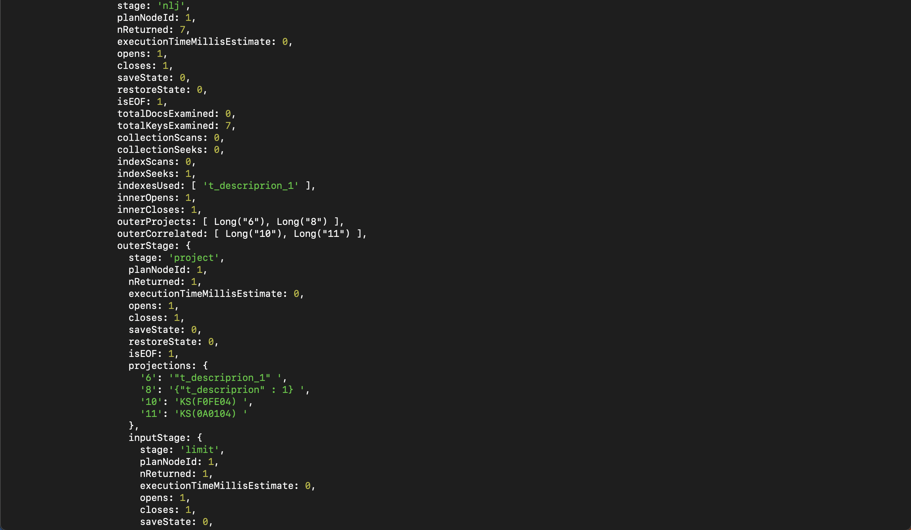

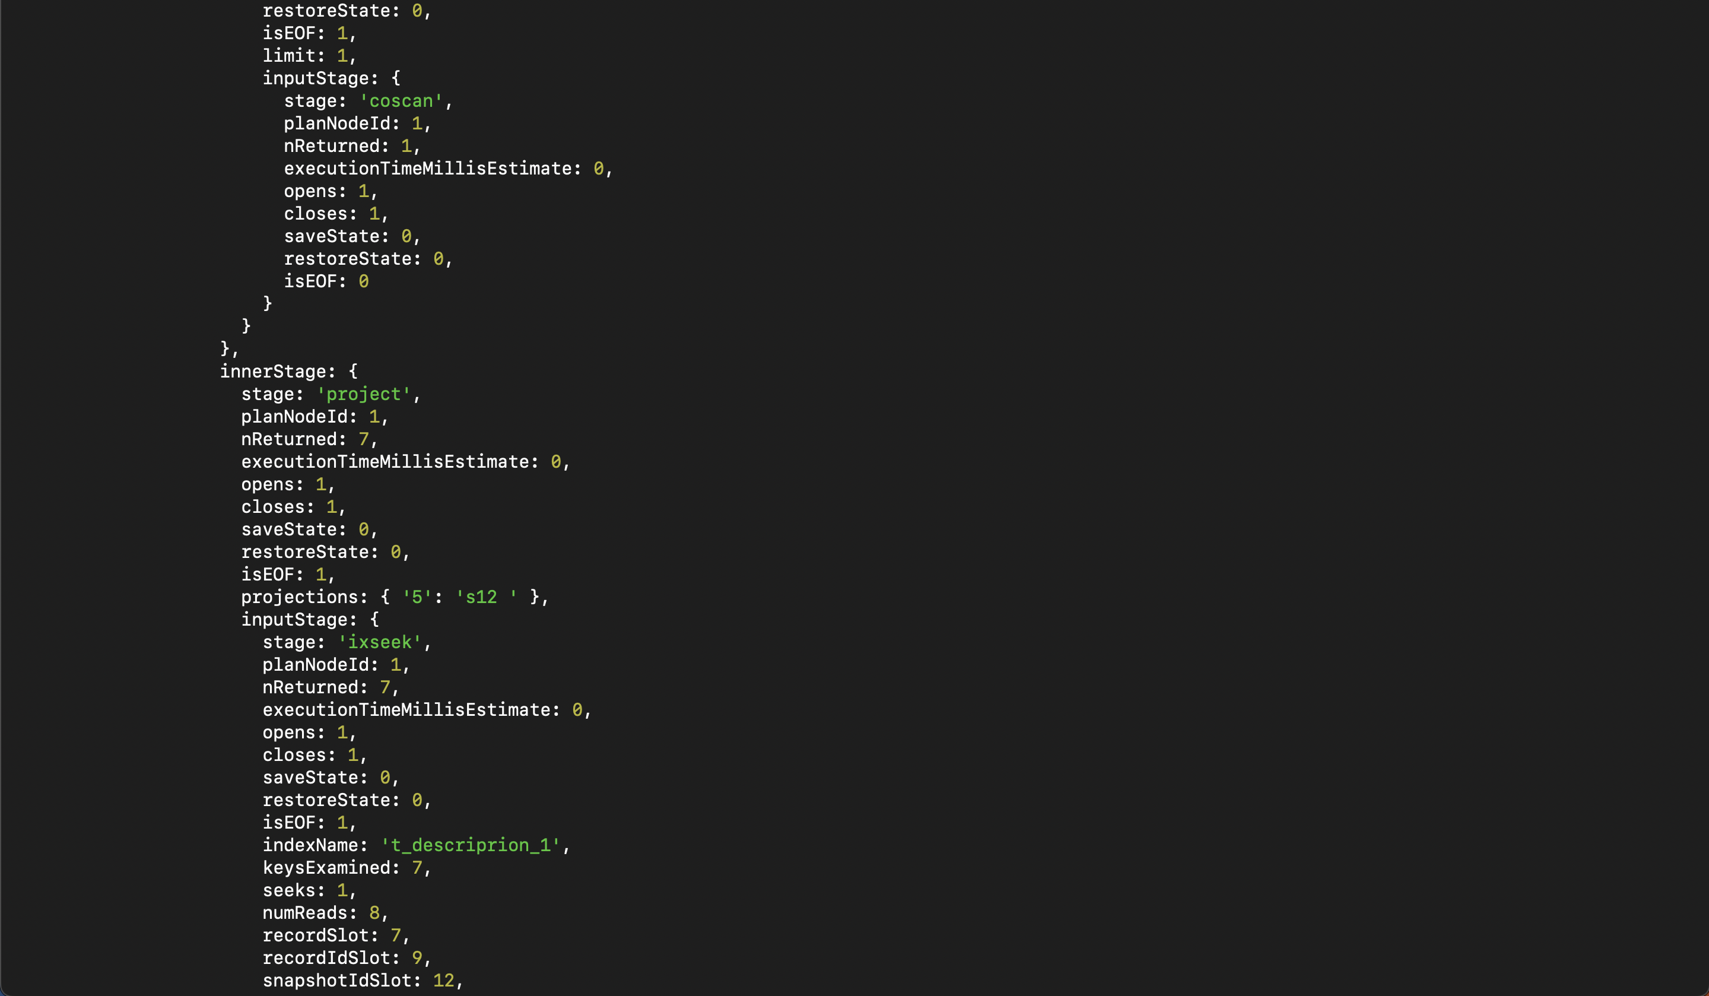

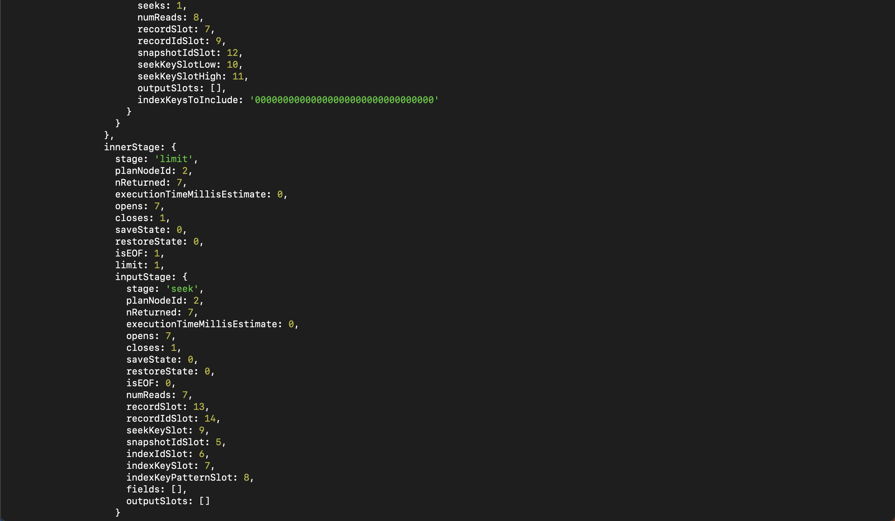

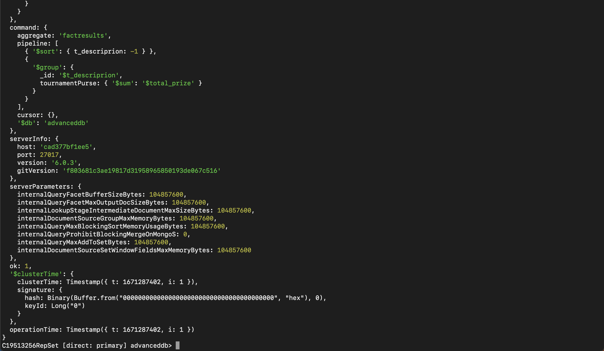

1. Replication working

<<pause/stop your primary node>>

<<use rs.status to show that another node has been elected >>

